LinkedIn: https://www.linkedin.com/company/rangbheeni/
Instagram: https://www.instagram.com/rangbheeni?igsh=YXhyMTVmZWNpYm15
Facebook: https://www.facebook.com/profile.php?id=61565762047664

Headers: Merriweather
Content: Open Sans
Optional Accent (Quotes / Pullouts): Playfair Display

Brand colors:

#09710d
#562b00
#099ec8
#84bc41
#7c3f00
#ffffff

Home Page
1. Our story
“Weaving change from Waste”

2. Impact Snapshot
Women Empowered: 32

Textile waste upcycled = 800 kg

Water Saved
800×14,000=11,200,000 litres800 \times 14,000 = 11,200,000 \text{ litres}800×14,000=11,200,000 litres
✅ Water saved = 11.2 million litres
(1 crore 12 lakh litres)

CO₂ Emissions Avoided
800×25=20,000 kg CO₂800 \times 25 = 20,000 \text{ kg CO₂}800×25=20,000 kg CO₂
✅ CO₂ avoided = 20,000 kg (20 metric tonnes)

🌍 Carbon Footprint Equivalents (to communicate impact)

🚗 Transport equivalent
- ≈ 83,000 km of car driving avoided
(using ~0.24 kg CO₂/km)

🌳 Tree equivalent
- ≈ 920 mature trees absorbing CO₂ for one year
(~21.7 kg CO₂/tree/year)

⚡ Electricity equivalent
- ≈ 24 Indian households’ electricity use for one year
Each customer contributes:
- 7,000 litres water saved
- 12.5 kg CO₂ avoided
Our Story preview:
Our Mission
To transform textile waste into sustainable solutions by empowering marginalised women with dignified livelihoods and supporting better educational opportunities for their children, ensuring those most affected by climate change become agents of change.
Featured Products

2. About Us:
Rangbheeni is a women-led grassroots initiative working at the intersection of textile waste, climate justice, and social equity.
India generates nearly 7.8 million tonnes of textile waste every year, much of which is burned or dumped near low-income settlements. This pollutes air, soil, and water, exposing socially marginalised communities, especially women and children to serious health risks. Textile waste also adds to greenhouse gas emissions, worsening climate impacts like floods and heatwaves that these communities are least equipped to face.
At the same time, women in these regions often remain unemployed or are pushed into unsafe, informal waste-picking work, while their children struggle to access education, continuing cycles of poverty and exclusion.
Rangbheeni transforms this crisis into possibility.
By upcycling discarded textiles into sustainable, handmade products, we create dignified livelihoods for marginalised women and invest in children’s education, making those most affected by climate change part of the solution, not its victims.
Every product carries a story of care, resilience, and hope stitched by women reclaiming control over their lives and futures.

Our Vision
A sustainable world where waste is reimagined as a resource, women lead inclusive climate action, and every child has the opportunity to learn and flourish.

Meet our team:

(collect it from the catalogue uploaded)

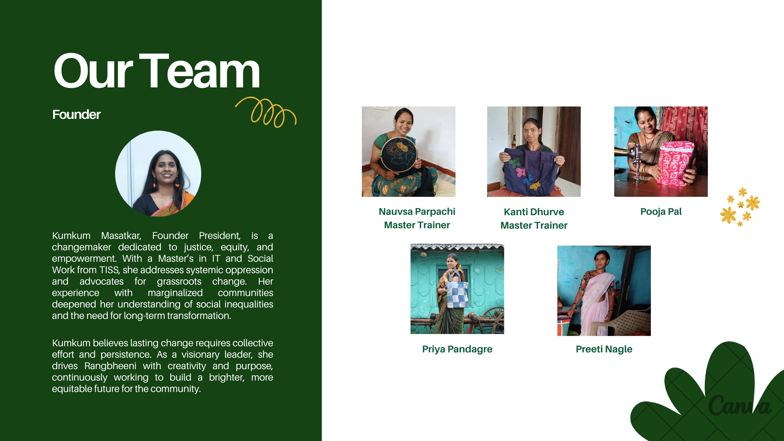

Advisors and consultants:

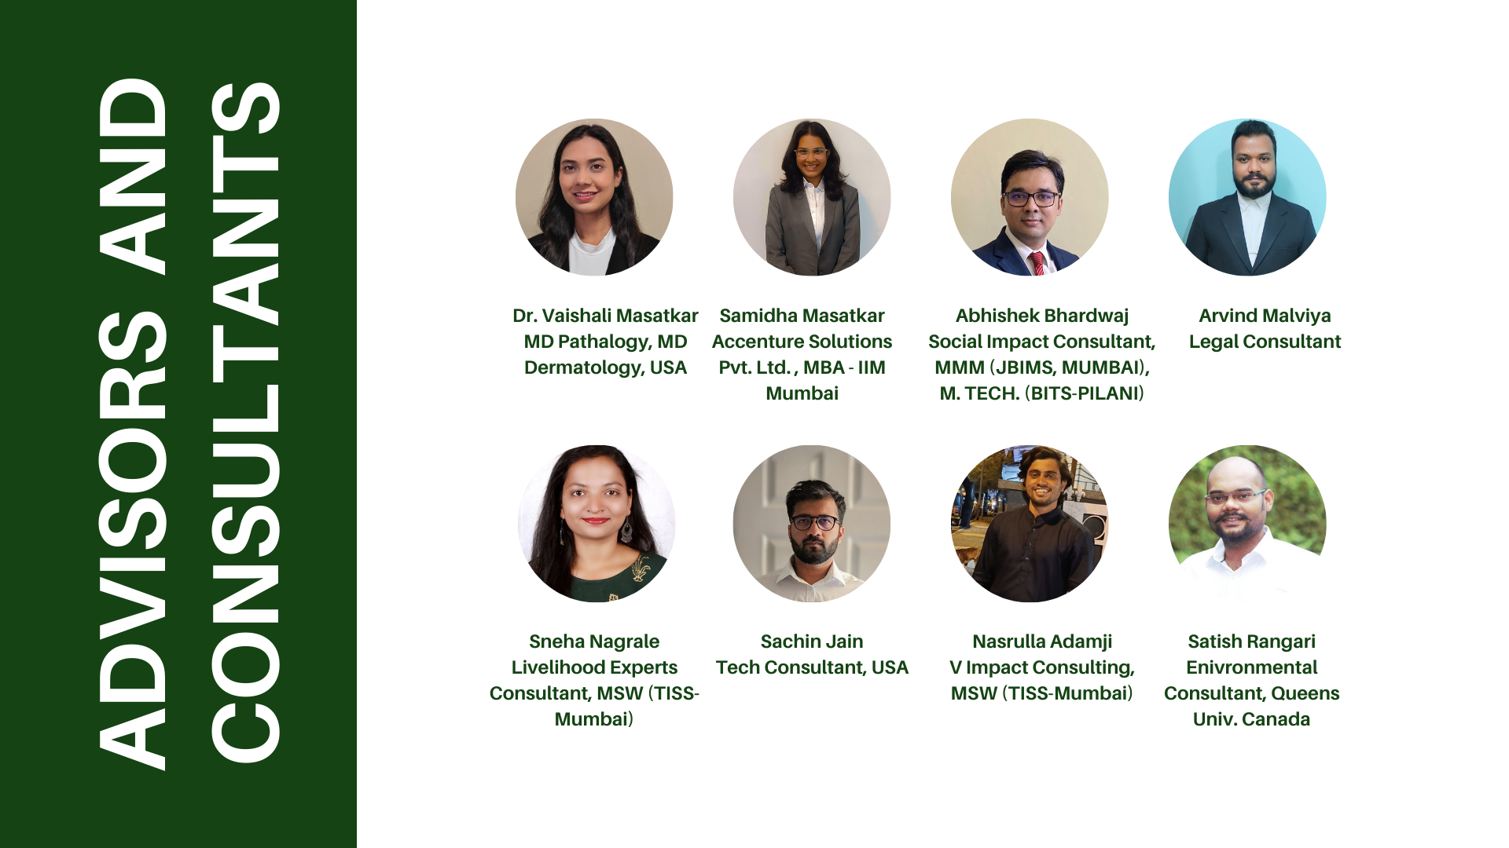

Timeline:

Approach:

What We Do
- Collect pre-loved clothes and textile scraps
- Train women from socially marginalised communities in upcycling skills
- Create sustainable, handmade products
- Generate dignified, climate-resilient livelihoods
- Support children’s education within the community
- Conduct sustainability and upcycling workshops for institutions and corporates

3.Products(uploaded on drive category wise)
- Categories: Bags, Accessories
- Corporate Gifts (could be separate section or atleast highlighted on home page)
- Filters: Price, Material, Collection.
- Impact Tag: Each product shows “Fabric saved: X kg” & “Made by: Anita & team”.
- Festive Offer

4. Impact
- Numbers: Women employed, income earned, fabric saved, CO₂ emissions avoided.(mentioned above)
- Stories: Short videos/blogs about women

- Map of Reach: Where workshops/products are present.

https://share.google/S5jXdmotkWg7vHOpM

